
Inspection of
HMP Rochester

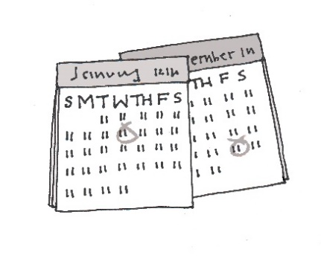
Inspectors visited this prison in August 2024.

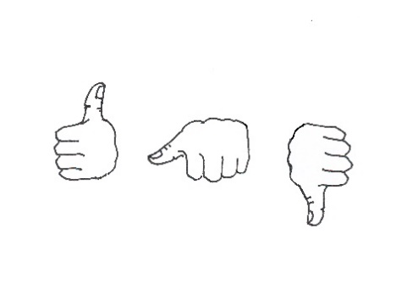

We wanted to find out if things were better, the same or worse for prisoners since we last visited in 2021.



We did this by:

- looking around the prison
- asking prisoners and staff to fill in a questionnaire
- speaking to prisoners
- speaking to staff and helpers
- reading documents.

What did we find?

Prisoners did not feel safe enough. There were too many drugs and too much violence. Too many prisoners were harming themselves.
We gave the prison 2 out of 4 for this.


The prison needed a lot of repairs and there were lots of mice and rats. Health care was not safe. Prisoners did not get enough help from staff.
We gave the prison 1 out of 4 for this.

There was very little for prisoners to do. Education and work was poor. Most prisoners did not go to classes or workshops.
We gave the prison 1 out of 4 for this.

Prisoners got very little help to do well in their sentence, or to get ready to leave the prison.
We gave the prison 1 out of 4 for this.

What should the prison do?

We want the governor to read our inspection report. You can find the report in the prison library.

We want the governor to make a plan. The plan should tell us how they will fix the problems at HMP Rochester and make things better for prisoners.
What do we want to happen?
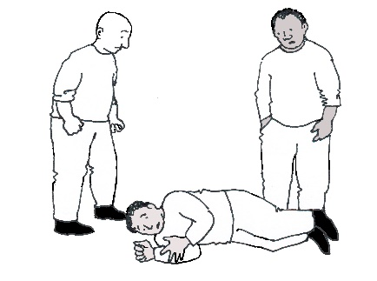

We want the prison to do more to make sure prisoners are safe.

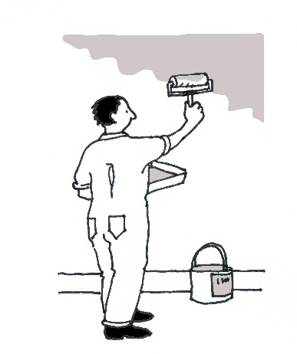

We want the prison to be repaired. We want the problem with mice and rats to be sorted out.

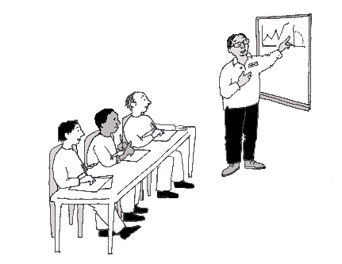

We want teaching to be better. We want prisoners to be able to go to education and work.

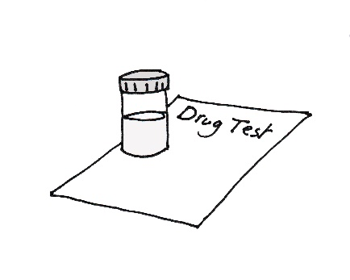

We want the problem with drugs to be sorted out.

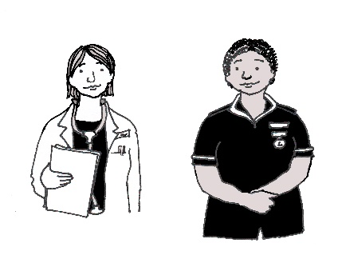
We want health care to be safe. We want prisoners to get the health care and medicine they need, when they need it.

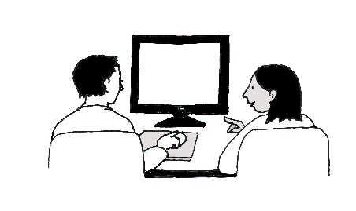

We want prisoners to be able to see prison offender managers. We want them to get help to do well in prison.



We want officers to help prisoners to behave well. We want officers to get more support from their managers.

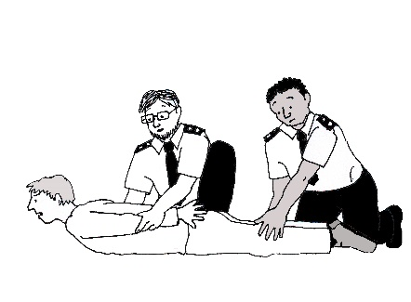

We want the prison to make sure staff only use force when they really need to.



We want all prisoners to be treated fairly.

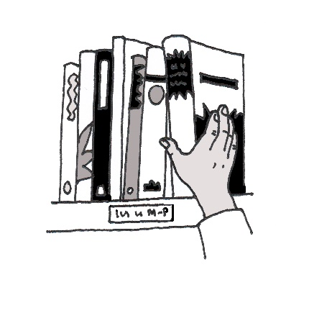
We want prisoners to get help with their reading.

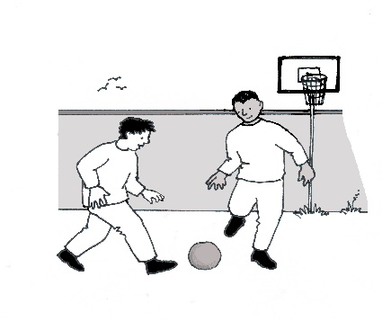

We want prisoners to have more to do.

What will we do?
We will come back in a few years to check how well the prison is doing. We will write a report to tell people what we find.

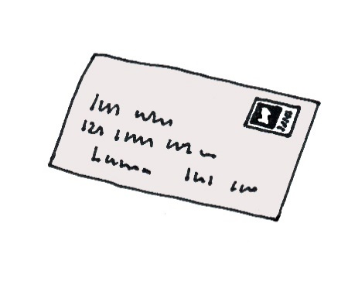
If you have any questions, please write to us:

HM Inspectorate of Prisons
3rd floor
10 South Colonnade
Canary Wharf
London
E14 4PU

