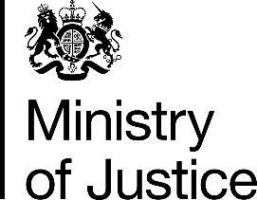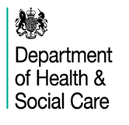
Independent Advisory Panel on Deaths in Custody
Keeping Safe Conference, 25 February 2020
AGENDA
The Abbey Centre
34 Great Smith Street, Westminster, London, SW1P 3BU

Arrivals and registration |  | 9.00am
Welcome and Introduction to Keeping Safe | Juliet Lyon CBE, Chair of IAP on Deaths in Custody  Erwin James, Editor of Inside Time | 9.30am
Welcome and opening address | Nadine Dorries MP, Parliamentary Under Secretary of State for Mental Health, Suicide Prevention and Patient Safety | 9.45am
Health and Justice working together to prevent deaths in custody | Kate Davies CBE, NHS England | 10.00am
Listening to and supporting people in prison | The Samaritans and former Listeners:  Hazel Alcraft  Magda Tomaszewska,  Berny Gardner and colleagues | 10.10am
Coffee Break |  | 11.15am
Learning from reports and recommendations to prevent future deaths | HHJ Alexia Durran, Deputy Chief Coroner  Sue McAllister CB, Prison and Probation Ombudsman  Dame Anne Owers, National Chair of Independent Monitoring Boards  Jonathan Tickner, HM Inspectorate of Prisons | 11.30am
Lunch – provided |  | 12.30pm
Emergency contact line for families | Andy Keen-Downs, Director of PACT and Cleo Metcalf, PACT | 1.30pm
Learning from families:  How to gain family support and keep people safe | Deborah Coles, Director of Inquest Donna Mooney and Mark Saunders, family members. | 1.45pm
Keynote speech | Robert Buckland QC MP Secretary of State for Justice | 2.40pm
Preventing self-harm –  research and practice | Professor Jenny Shaw and  Professor Seena Fazel | 3.10pm
‘Prison - no place of safety’ launch | Andrea Albutt, President of Prison Governors Association and Gabrielle Lee OBE, HMPPS | 3.50pm
Closing remarks | Phil Copple, Director General of the Prison Service | 4.00pm
End |  | 4.15pm

