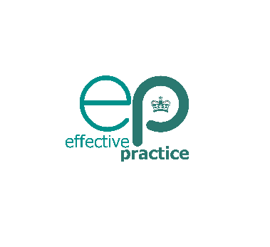
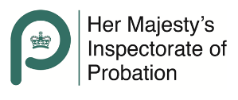

Black and mixed heritage boys in the youth justice system

Reflecting on the input and the reports:
What do you plan to stop doing as a result of your reflections?
What do you plan to continue doing as a result of your reflections?
What do you plan to start doing as a result of your reflections?

Moving forward I pledge to:
What  e.g. I plan to read X; I plan to ask how culture impacts on all aspects of a child’s life | Why | How will I do it…  e.g. be specific about time allocated and what specific action you plan to do | How will I hold myself accountable…  e.g. I will discus in supervision, I will pick an accountability partner to discuss learning/impact

