

Operational Security Group
Directorate of Security
102 Petty France | London | SW1H 9AJ

Central Authorisation for Prisoner Escort Contractors Services (PECS) | October 2025
Dear All,

This note is to advise prisons that a central authorisation has been provided under section 40E of the Prison Act in respect of any prison or Young Offender Institution for Prisoner Escort Contractors (GeoAmey,Tascor, Serco etc) undertaking delivery/collection of prisoners the following technology:

Mobile phones
PECS are authorised to convey into the prison, possess and use within the prison, and take out of the prison an approved work issued mobile device for logging details of prisoners and to allow escort staff to record related prisoner-information such as potential security risks, self-harm issues and medical needs.

PECS are also authorised to use these devices to transmit information from inside the prison for simultaneous reception outside the prison if this is required for operational purposes.

Technology devices
PECS suppliers can take the technology described below into all HMPPS prison establishments.

Devices employed by both GEOAmey and Serco
Microlise  - Current technology - It is provided in the form of a tablet secured into the front cab of a vehicle. It provides a tracking and telematics functionally, trip sheet, integrated satellite navigation, task management and ability for voice calls and text messages. | 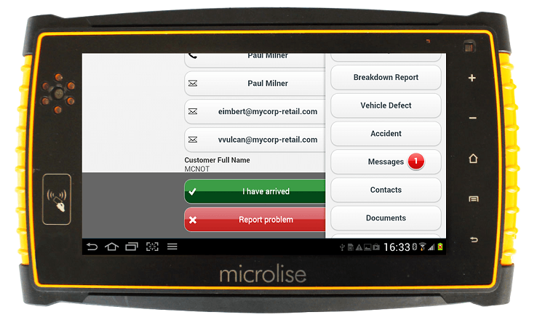
Devices employed by Serco  - Samsung A23 and A26 (known as Vera devices) with Serco’s locked-down build  - The Samsung devices access Serco’s SERS application to record the movement of subjects from Prison or custody suite locations to court attendance and for any subsequent onward journeys  - The Samsungs are used to access Google maps as a contingency when the Microlise device is unavailable.  - Devices are data only and do not have any voice capability. | 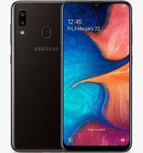

Devices employed by GEOAmey
- Samsung Galaxy Tab A8 LTE 8 inch tablet device  - The Samsung Tab A8 supports the GEOTransport application, employed to record the movement of subjects from Prison or custody suite locations to court attendance and for any subsequent onward journeys. Devices are data only and do not have any voice capability. The device will be fixed into a holder carried by the GEOAmey Officers at all times when outside of a vehicle. | 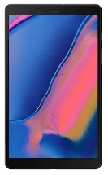

Security requirements

- Prisons must log the devices in and out of the prison, any devices found to be missing must be investigated and traced by the escort contractor.
- In the event of a device being lost or stolen, the contractor will ensure that the data function of the device is disabled remotely so that it cannot be used.
- Personal mobile phones must be handed in at the gate and secured in a locker for the duration of the visit.

As with other items, prisons may impose additional administrative restrictions on items allowed into the prison where considered necessary and proportionate on the grounds of security.

Andy Rogers
Deputy Director, Operational Security Group
Directorate of Security

